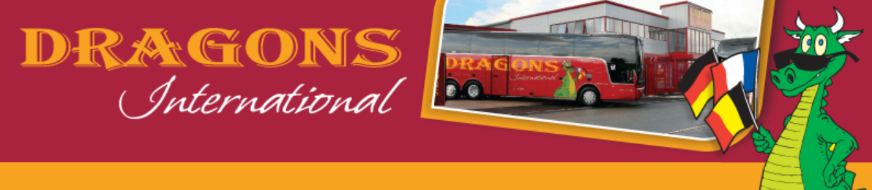

**www.dragonsinternational.co.uk**

Day Trips 2016

CHRISTMAS MARKETS

**🖂 Info@dragonsinternational.co.uk 🕿 01785 224420**

**Markets to**

**★ Aachen ★ Köln ★ Koblenz ★ Bonn ★ Cochem ★ Trier ★ Rüdesheim ★**

**Travel by 49 or 53-seater executive coach with reclining seats, seat-belts, DVD player and toilet.**

**TYPICAL ITINERARY FOR YOUR EXTENDED DAY TRIP**

**Day 1:**

Evening - Executive coach collects your group and drives to Folkestone/Dover.

**Day 2:**

*Early morning* - Channel crossing by shuttle or ferry.

*Mid-morning* - Arrival at Aachen or Köln

**Approximately 10 hours free time to enjoy the Christmas Markets.**

*Evening* - Coach departs

**Day 3:**

*Early morning* - return Channel crossing.

*Mid/late morning* – arrive back at your destination.

**★Optional Activities★**

**Guided tours** of your chosen destination

**Two-Hour Advent Boat Cruise** on MS RheinEnergie or MS RheinFantasie

See, feel and taste chocolate at the unique **Chocolate Museum**

Visit the **Deutsches Sport & Olympia Museum**

An insight into the history and ever-changing face of sport

*All can be pre-booked by us.*

**An ideal opportunity to practice language skills and experience this fascinating German tradition.**

***WHAT HAPPENS WHEN YOU BOOK?***

On acceptance of our quotation in writing, you will receive our full confirmation pack including:

**Confirmation letter and invoice** (Deposit only £500 per coach; Balance due one month before departure)

**Personalised itinerary** with dates, times and travel arrangements

**Checklist, advice, safety information and notes for your group**

Relevant forms for completion

**Tourist information on the city you have chosen to visit**

**Follow-up service after your return**

**From £2550**

**★**Email us today for a quote on info@dragonsinternational.co.uk or call 01785 224420**★**